5th Annual International Conference on Evidence Based Library and Information Practice (EBLIP5)
Session Summaries

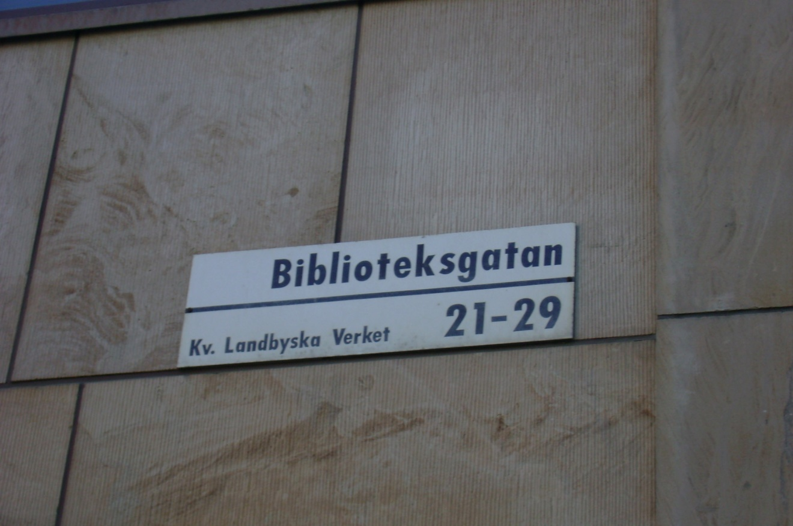

Photo of Library Street (translation from Swedish) Sign in Stockholm
This street leads to the National Library of Sweden

Executive Summary
I learned a lot from this conference, especially about information literacy which was one of the hot topics at the conference along with knowledge management. It was a great opportunity to get a more international perspective on issues that affect all librarians and researchers. All of the presentations are available on the EBLIP5 website: http://blogs.kib.ki.se/eblip5/parallel-sessions.html and http://blogs.kib.ki.se/eblip5/keynote-abstracts.html

Parallel Session I

“Students’ Use of Virtual Reference” by Lorna Rourke and Pascal Lupien
This presentation was on Rourke and Lupien’s systematic review of the reference literature. A systematic review of the literature has never been done before on the topic of virtual reference. They found inconsistent results among the different studies in the literature with regards to the percentages of different types of reference questions asked via virtual reference (ex. specific searches versus in-depth questions, etc.). Future research will include investigating why there are differences among institutions and finding ways of consistently evaluating services.

“Bridging the Two Research-Practice Gaps in Knowledge Management” by Sonja Gust von Loh and Wolfgang G. Stock
According to Gust von Loh and Stock there are two gaps in knowledge management: the gap between employees and researchers and the gap between researchers and research studies. In order to bridge these gaps, we need to broaden the scope of EBLIP and need to work towards EBKM which would be a blend of knowledge management, user and usage research and EBLIP. This presentation was very interesting in its approach to bringing EBLIP into knowledge management.

“The Qualitative Evidence Base for Library and Information Practice” by Andrew Booth
Andrew Booth is one of the founders of EBLIP and this presentation was on some of his most recent research that expands beyond his usual focus on quantitative research. Through his review of the evidence base, he determined that only 11% of the published literature in library and information sciences can be considered qualitative research. Interviews, surveys and observations are the most common methodologies used in qualitative studies. This study is not prioritizing qualitative research over quantitative research, or vice versa. Obviously, there is much room for future qualitative studies in all areas of library and information science.

Afternoon Keynote Summary

“The Potential Contribution of Social Informatics to EBLIP” by Anita Mirijamdotter
This talk was about incorporating systems thinking from social informatics into EBLIP. Mirijamdotter suggested a framework of international collaboration for EBLIP in order to support research. This is looking at a more participatory approach to research in order encourage a “research culture” and a sustainable learning organization.

Parallel Session II

“Connections, Reflections, and Redirections: Bridging Research and Practice in Information Literacy” by Margy MacMillan
MacMillan presented on the creation and use of the I-SKILLS Resume as a way of evaluating student learning of information literacy. The I-SKILLS Resume is freely available to use and is a very interesting way of approaching the evaluation of IL skills as well as a way of using research to inform practice. I highly suggest looking more in-depth at MacMillan’s research.

My presentation was in this session.

July 1st Morning Keynote

“Bridging the Gap between Service Provision and Customer Expectations” by Sue McKnight
McKnight focused on using the Customer Value Discovery methodology in order to gather evidence to enhance services for customers. This methodology uses workshops where staff and customers participate together. There are no pre-defined questions and this allows customers to actually tell the staff what they think about the services without using leading questions. This methodology closely mirrors focus group methodology. When McKnight implemented this methodology at her library she found that there were great disparities between how the staff saw customer needs and what the customers valued at the library. This is one way of evaluating services and using the results to improve services with input from all staff members.

Conference Showcase

“Applying Evidence to Practice” by Prudence Dalrymple
Dalrymple went over many different theories and methodologies that can be used in EBLIP and research in general. She is most interested in the diffusion of innovation theory which takes into account innovation, communication channels, rate of adoption and social context when determining how and when a new innovation or technology will be adopted or become ubiquitous. Much of this theory is common sense, such as having good communication with others improves the rate of adoption and if the innovation can be easily integrated into the workflow it will have a better chance of success.

Afternoon Keynote

“Conditions for Research Use in Library and Information Practice: A Matter of Learning” by Ola Pilerot
Pilerot focused on the social contexts in which people use and understand information and information literacy. He wants to problematize EBLIP in the way that postmodernity problematizes history, for example. Pilerot posits that because people are not rational, research needs to take this into account. He prefers the Research-Practice Continuum (Donald McIntyre 2005). This was an interesting keynote that made people think beyond what has often been seen the boundaries of EBLIP and challenges us to integrate new theories and methodologies into EBLIP research.

Parallel Session III

“Evidence-based Practice to Enhance Collaboration between Faculty and Librarians as Teachers” by Katarina Jander and Yvonne Hultman Ozek
Jander and Ozek focused on improving a compulsory research course for postgraduate students. They worked with the discipline faculty through constructive alignment to improve the course. This led to changing learning outcomes and assessments. It also improved the collaboration between the faculty and the librarians.

“Research Circle as a Method for EBLIP” by Kerstin Rydbeck
The research circle comes out of the study circles which are a Swedish phenomenon. The circles focus on collective learning processes as an act of empowerment on the part of the students. This research was conducted using school librarians as the circle participants. These circles provide good venues for discussing issues and determining solutions to common problems. However, the circles require a lot of time on the part of the participants and support from employers is necessary to free up time for the librarians to participate.

July 2nd Keynote

“Bridging the Skills Gap: Shaping the Information Professional of the Future” by Birgitta Olander
Olander brought the perspective of a LIS educator to her keynote. It is almost impossible to predict the professional life of librarians 30 years from now; therefore, there needs to be a program of sustainable education that includes the mastery of new skills through continuing professional development. LIS educators must do environmental scans in order to prepare students for careers in a field in rapid flux. The most important skills needed are the ability to learn throughout a lifetime and the openness to change.

Parallel Session IV

“From Evidence to Action: A Shared Leadership Approach” by Denise Pan
Pan presented on how the Technical Services department was reorganized to reflect a new emphasis on e-resources. This library used Evidence Based Shared Leadership which incorporated shared leadership (moving beyond a hierarchy), appreciative inquiry (each individual had a voice in the process), and knowledge creation (communities of practice). Open communication was central to the success of this reorganization that shifted staff members into new jobs that aligned the staff members’ strengths and interests with their job duties.

“An Evidence-Based Approach to Studying Workforce Issues in Library and Information Science (WILIS)” By Joanne Marshall
WILIS was a collaboration between UNC Chapel Hill and the Institute on Aging to understand the state of the library workforce in order to facilitate succession planning. This study again underscored the projected coming shortage of librarians as many of the older librarians retire. However, this study was completed before the current economic recession, so I do not know how much of this information still is accurate.

“Mining the Evidence: Situating Planning, Participation and Leadership within the Academic Library Culture” by Lyn Currie, Patricia Moore and Carol Shepstone
This study looked at the current versus preferred culture in three different libraries. Currie, Moore and Shepstone used the Competing Values Framework (CVF) for this study. According to this model there are four culture types (Clan, Adhocracy, Market and Hierarchy) and each type has different attributes. The results showed that two of the libraries had fairly similar current and preferred cultures and one library had very different current and preferred cultures. All of the preferred cultures were a mixture of clan (characterized by team-work, loyalty and tradition) and adhocracy (characterized by creativity, vision, experimentation, and change) cultures. These results can be used to move an organization closer to the preferred culture.

Closing Thoughts
This was an excellent conference and it was great to get an international perspective on so many issues. Also, I gained many ideas on different methodologies to use in my own research. If you have any questions, I am happy to talk more with you about EBLIP or anything else about the conference. The destination for the next conference, in 2011, has not been decided yet.

The island of Riddarholmskyrkan

